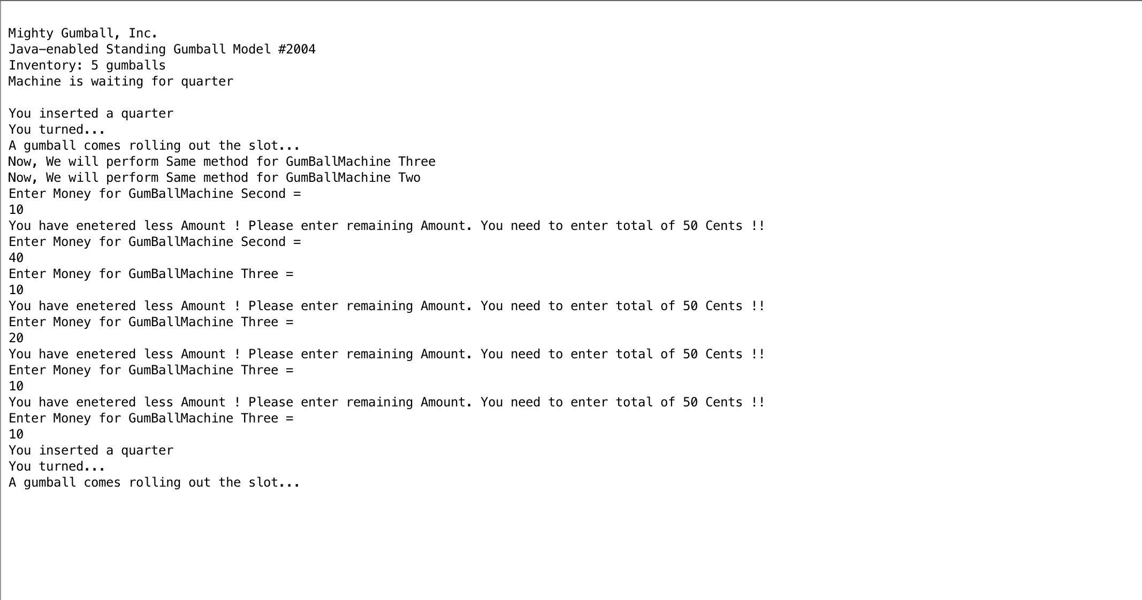

I have added Two separate classes for Gumball machine two and Gumball machine three. These classes use same method as the Gumball machine one.

Class Diagram 🡪

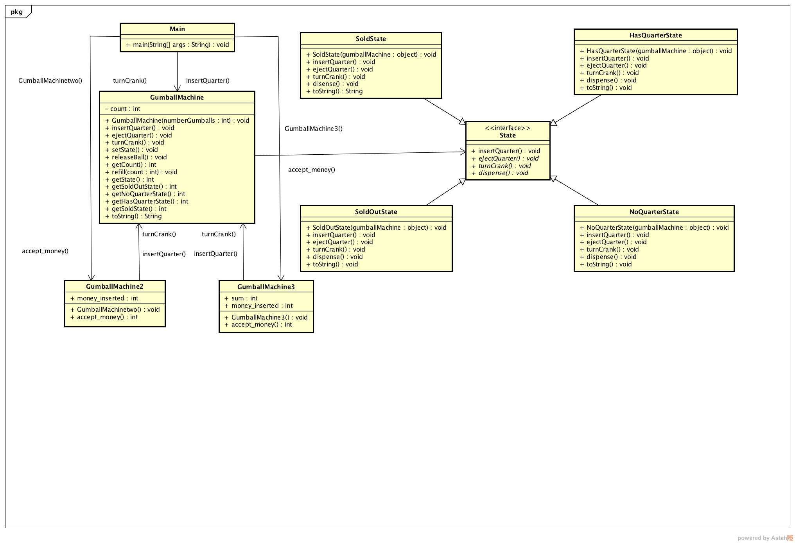

Link for second part of coding 🡪

**https://github.com/laxmikantbpandhare/cmpe202/tree/master/lab1/gumball-java-pattern**